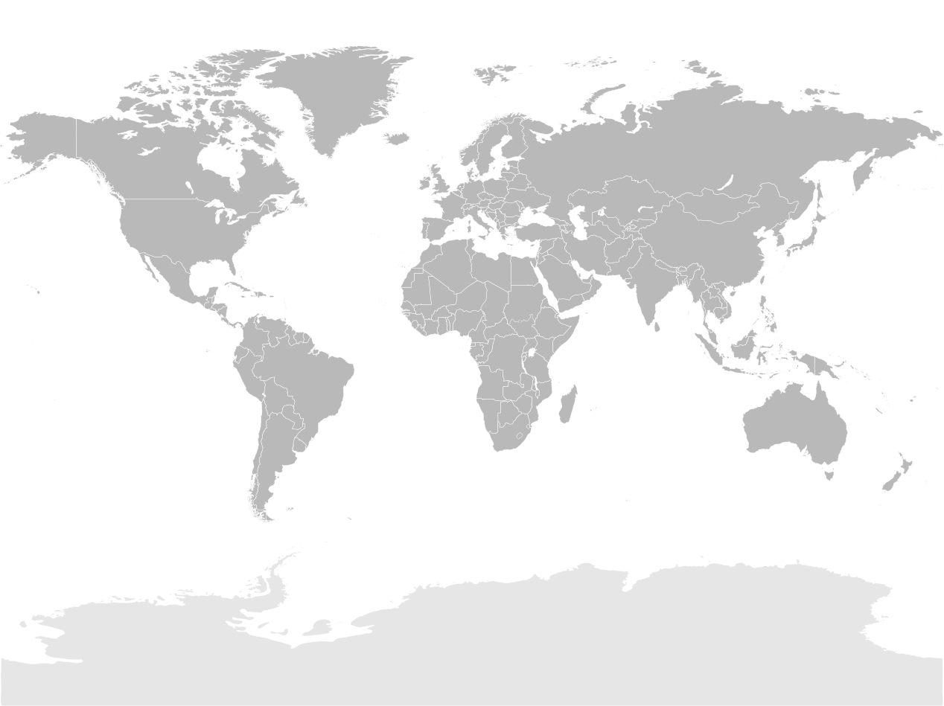
My Colourful Kite: Nick’s Story
Eva Raue (1/2)
On the map to the left, colour in the country where Eva Raue was born.
Then, find a picture of the following things and paste them in the spaces below.

Some famous limestone cliffs.

A volcano in this country.
My Colourful Kite: Nick’s Story
Eva Raue (2/2)
On the map below, colour in the country where
Eva Raue was born.
Then, find a picture of the following things and paste them in the spaces below.
This university is ____ years old.
A picture of an endangered
animal in this country.
A photo of the oldest
university in this country. Find out how old it is.

